**TRUST PERFORMANCE & QUALITY REPORT**

**April 2024**

**NHSI Reporting**

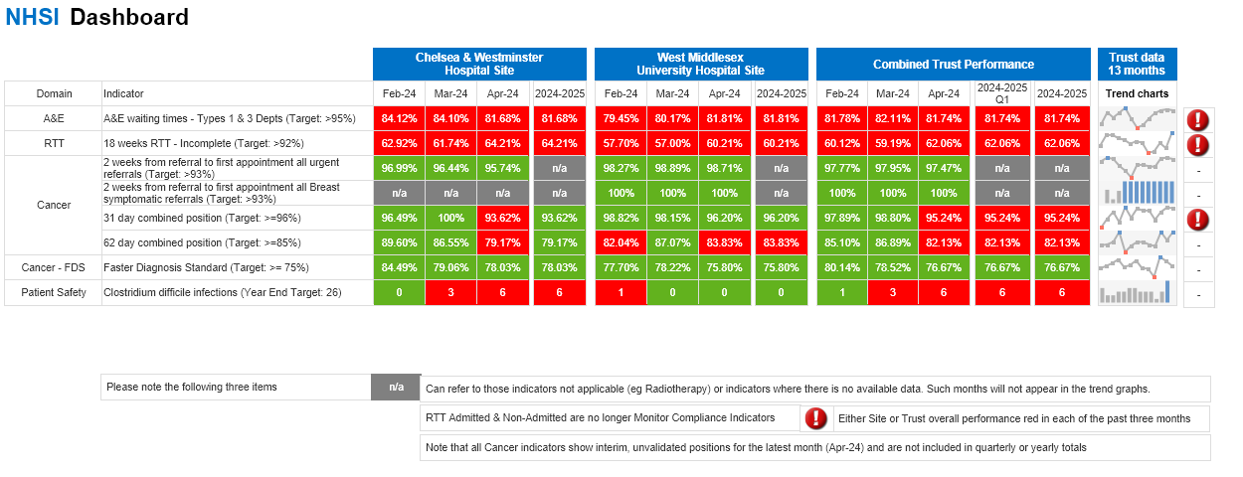

**A&E 4-hr Waiting Times**

The Trust performance in the month of April 2024 at 81.74% is above the national target (78%). Performance by site shows an improving position at West Middlesex, from 80.2% in March 2024 to 81.9% in April, with Chelsea reporting a decrease in performance when compared to the previous month. This reflects a challenge to site wide flow at Chelsea and discharge challenges relating to external equipment supplies for Chelsea patients. The flow challenges has led to congestion in the department, with longer waiting times for admission (median admitted waiting time up 51 minutes) and more breaches. Non-admitted waits rose 4 minutes in the same period.

**18 Weeks RTT (Incomplete Pathway)**

Elective Referral to Treatment (RTT) 18-Week Wait performance remained challenged but stable in April 2024, standing at 62.06%. Elective admitted and outpatient activity levels increased in April and above operational plans. Overall, activity levels remain strong going into the new financial year. For April 2024, the total RTT Patient Treatment List (PTL) decreased to 60,790 (-1388), 52ww decreased to 1,694 (-233), 65ww decreased to 302 (-10) and 78ww decreased to 37(-18). Operational teams remain focused on expediting long-waiting pathways and enhanced oversight and targeted interventions continue for at-risk specialities: Trauma & Orthopaedics, Colorectal Surgery, Plastic Surgery and General Surgery. To support reduction backlogs, trajectories have been set with a plan to eliminate the 78ww by July 2024 while the 65ww is forecasting 90 patients on the pathway at the end of Sept 2024.

**Cancer** *(Final Previous Month, Unvalidated Current month)*

**31-Day**: The 31-day combined target maintained performance for March 2024 (validated) and April (unvalidated) of 98.8% and 95.24% respectively. There has been a steady rise in performance against this target in recent months.

**62-Day:** The 62-day combined target was compliant in March 2024 with a performance of 86.89% against the 85% standard. The April position is currently unvalidated and is challenged, currently reporting 82.13% due to a high volume of breaches in Urology. Diagnostics have been somewhat challenged with reduced capacity following equipment failures in CT and MRI which has had an adverse impact on this target. Recovery plans to improve diagnostic capacity is in place and monitored at the appropriate forums.

**28-Day FDS:** The FDS target was complaint in March 2024 with a good performance of 78.52% against the 75% national standard. The Trust is committed to deliver the NHS Operating Plan Standard of 77% from April 2024. April 2024 reports an unvalidated position of 76.32% with some improvements expected.

**Clostrium Difficile**

There were 6 Trust apportioned CDI cases in April 2024, targets for the 2024/25 financial year are yet to be published. All cases occurred at the CW site, 3 were Hospital Onset - Healthcare Associated (HOHA) diagnosed on or beyond day 3 of their admissions and 3 were Community Onset - Community Associated (COHA) diagnosed within 2 days of their admission but with a previous admission within 28 days to CWFT.  3 cases occurred in the Emergency and Integrated Care division, 1 in the Specialist Care division and 2 in the Planned Care division.  A deep dive of all six cases is currently being undertaken.

**SELECTED BOARD REPORT NHSI INDICATORS**

**Statistical Process Control Charts for the last 36 months Mar 2021 to Apr 2024**

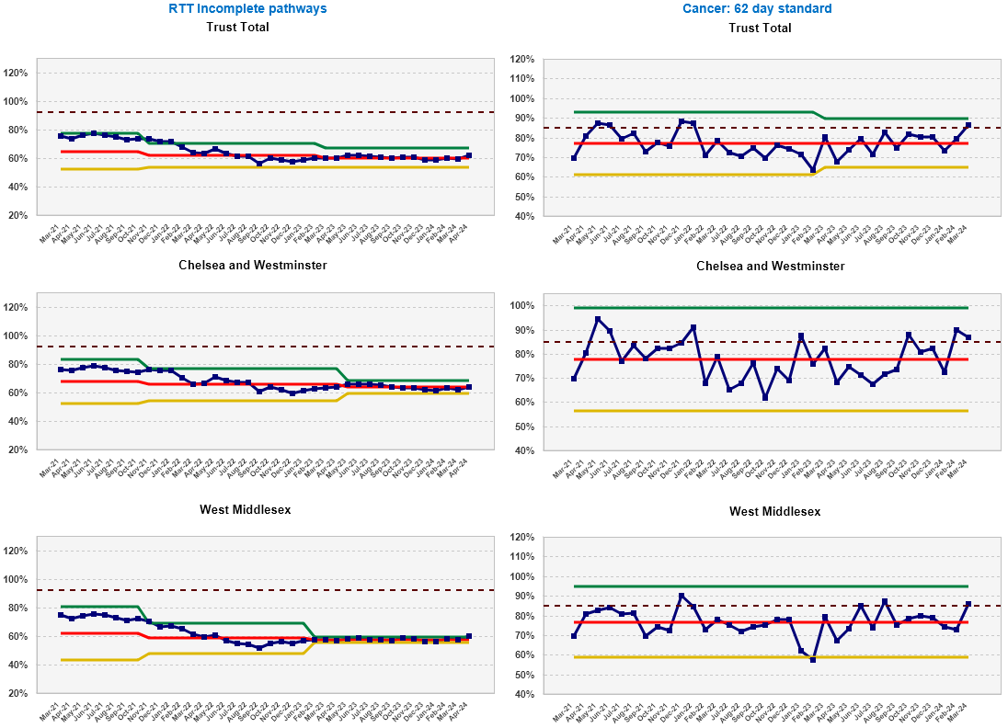

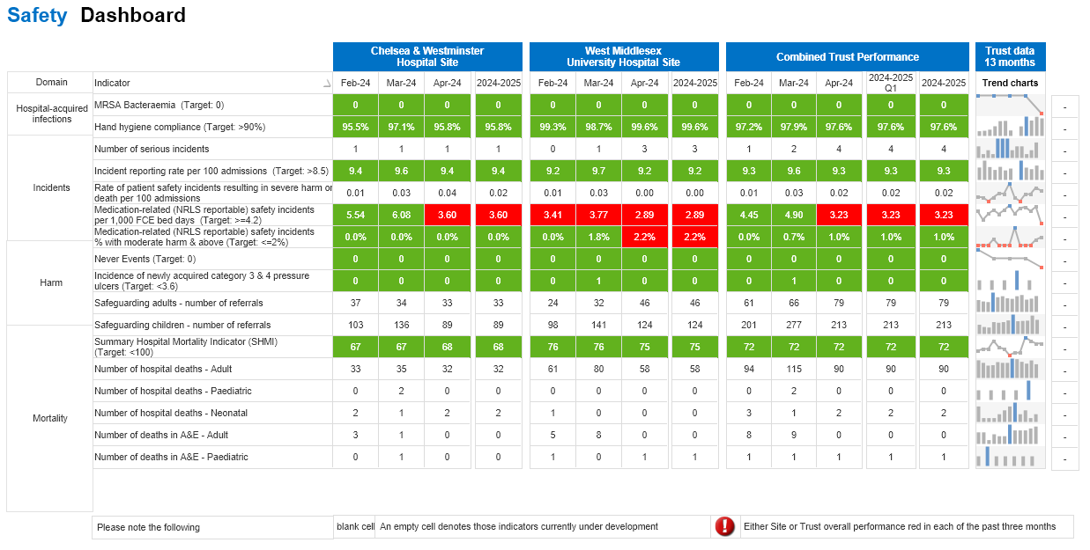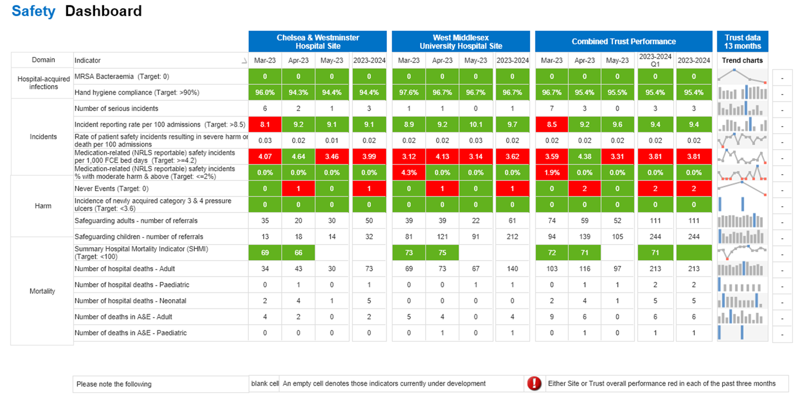

**MRSA**

There were 0 Trust attributed MRSA bacteraemia in April 2024.

**Hand hygiene**

Trust Hand hygiene compliance was 97.5% in April 2024,  99.6% at WMH and 95.8% at CWH, well above the local 95% compliance target

**Incidents**

There were four PSII’s declared in April 2024; three cases are being reviewed by The Maternity and Newborn Safety Investigations (MNSI) programme and relate to unexpected admissions to NICU. The fourth PSII is also an unexpected admissions to NICU and is being investigated locally as it did not meet MNSI criteria, however, there were parental concerns. Initial Incident reviews have been discussed at the IIR group and immediate safety actions / areas for improvement have been taken to minimise risk of recurrence.

During the target month (April 2024 2023) the target rate of patient safety incidents per 100 admissions was exceeded by both sites. It is anticipated reporting rates will increase following the implementation of the Patient Safety Incident Response Framework (PSIRF) and Learning From Patient Safety Events (LFPSE); staff training will be an integral part of the roll out.

**Medication-related (NRLS reportable) safety incidents per 1,000 FCE bed days**

In light of the decline in the reporting rate for medication-related incidents cross-site, the following action will be undertaken by the MSG: review and analysis of reporting by location to identify and explore specific areas of poor reporting as supported by the nursing MSG co-chair, to target education and awareness around the importance of reporting medication-related incidents of all degrees of harm via nursing meetings.

**Medication-related (NRLS reportable) safety incidents % with harm**

There was one incident of moderate harm reported at WM site relating to NAC infusions in a paediatric patient which is pending investigation. Further information is pending from the information team to confirm whether Trust target has been exceeded.

**Safeguarding**

Activity remains consistent across both adult and children safeguarding. Cases continue to be complex with a high proportion also including mental health services and the themes remain consistent.

**Safety**

**RTT 52 Weeks**

**62 Day Cancer Standard**

**RTT 52 Weeks**

**Patient Experience**

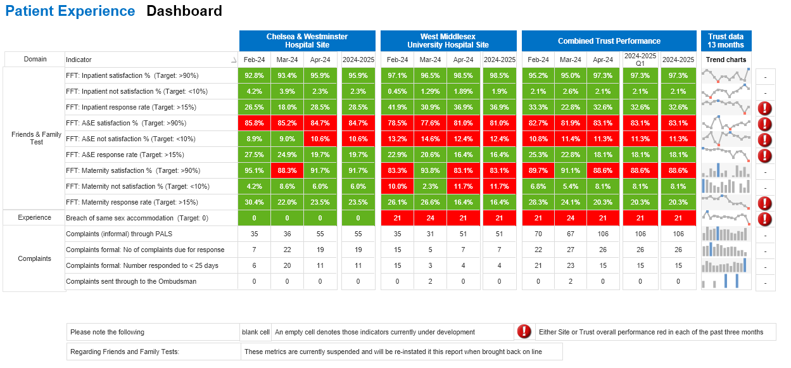

**MSA (Mixed Sex Accommodation)**

Guidelines for the Provision of Intensive Care Services” dictate that patients should be transferred from critical care to a ward within four hours of the decision. Unfortunately, West Middlesex experienced 21 instances in April, down 3 compared to March, where this standard wasn't met, resulting in patients remaining in mixed-sex areas. Breach details: 8 patients waited over 10 hours for a ward bed, with 1 exceeding 30 hours. We have seen a welcome decrease in delay times for April. We have managed to half the number of patients’ waiting 10 hours or more. We have included a 'Discharges for Bed Manager' folder on our shared drive to assist in bed allocation. The service is also developing a live dashboard which can be accessed by the team, both internal and external to AICU, which can relay live potential breaches. As always, patient care remains our top priority, and we continue to uphold their dignity and cultural considerations in all situations.

**Complaints**

33 out of 40 (82%) complaints were responded to within the 25 day KPI (target 95%) during April 2024. Seven complaints were not responded to within the timeframe; one for EIC, three for PCD and three for Specialist Care. This was in part due to delays in receiving the investigation outcome/draft response. Compliance with responding to PALS concerns within 5 working days was 84% (KPI 90%) this has been partially due to the PALS team not receiving outcomes on time and partly due to PALS staff availability in April 2024

**Friends and Family Test`**

Improvements from March have been seen in response rates/totals in inpatient areas and maternity satisfaction at CW. There have been drops in A&E response rates and this is attributed to budget control. The most concerning metrics are the declines in experience and response rates in maternity wards at West Middlesex. Women are voicing their unhappiness with many aspects of their maternity journey and it factors around a number of different themes. All of this feedback is being triangulated into the newly refreshed postnatal patient experience working group and matrons will be taking more of a proactive stance in addressing this type of feedback going forward as part of the weekly audits.

**Efficiency and Productivity**

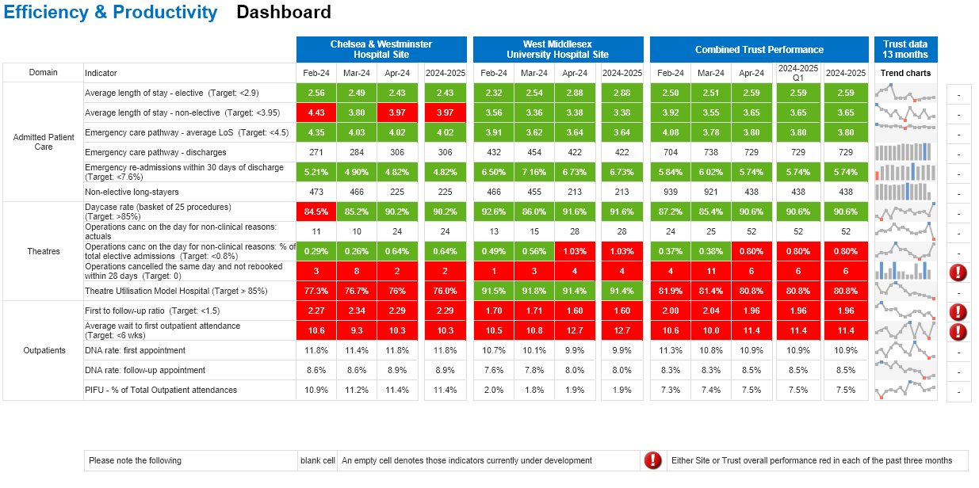

**Day-Case Rate**

The day-case rate improved in April 2024 going up to 90.6%, remaining well above the 85% target. The improved performance was seen across both sites.

**Cancelled Operations**

The number of cancelled operations for non-clinical reasons on-the-day increased Trust-wide in March from 25 to 52. This increase was seen on both sites, and was largely driven by on the day sickness for several surgeons, along with estate issues and list over-runs. 6 of these patients were not rebooked within the 28 day target. This a key focus of improvement work, with an aim to see this decrease from May.

**Theatre Utilisation**

Trust-Wide utilisation declined slightly in April to 80.8%. Theatre utilisation remains significantly above the 85% target at 91.4% on the West Middlesex site. The Chelsea site remains below the 85% target, and has driven the Trusts slight decline for April, falling to 76 %. Across the Chelsea site, theatre utilisation remains well above the 85% target in Main Theatres, however decreases in utilisation in Treatment Centre and Paediatric Theatres account for the deterioration.

**Outpatients**

There was an improvement in both Patient Initiated Follow Up and the Trust’s first-to-follow-up performance in April against March data at both sites. The PIFU in particular is trending positively, while DNA rates remain broadly static despite the focus at Outpatient Board. The average wait to first attendance remains high, especially at WMUH where the new waiting list is longer. The Trust’s DNA rate dipped slipped slightly in April compared to March’s performance.

**Clinical Effectiveness**

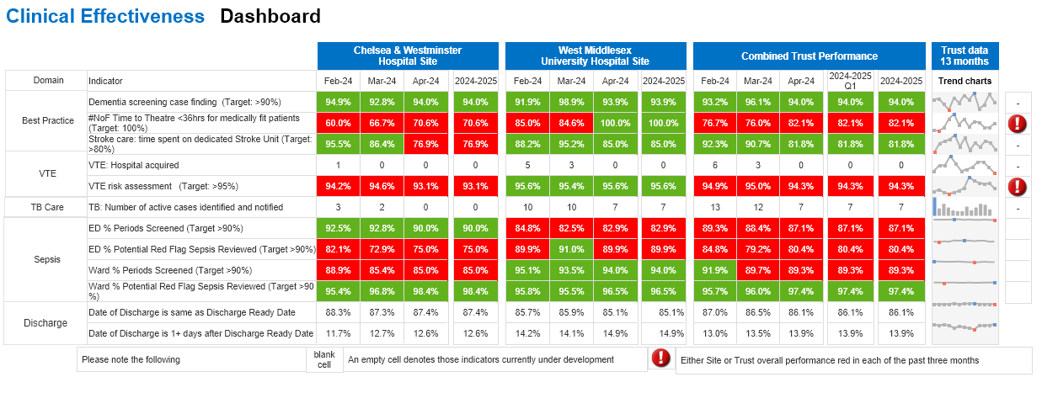

**Dementia Screening**

In April 2024, the Trust target of 90% and above for dementia screening was achieved on both sites; WM at 93.9% and CW at 94%.

**#NoF** ***(Time to Theatre*** -***Neck of Femur)***

Improved performance was reported in April compared to the previous month with West Middlesex achieving 100% compliance, whilst Chelsea site though challenged, showed improvement.

In Chelsea 12 out of 17 patients medically fit for surgery had surgery within 36 hours. All five patients who breached were awaiting space on the trauma list due to high volume of trauma.

**VTE Risk**

West Middlesex Hospital site continues to meet the >95% target for VTE risk assessment (95.6%). All Hospital Acquired Thrombosis events undergo RCA to ensure adherence to guidelines and appropriate learning. Chelsea site continues to meet the >95% target for VTE in EIC but areas for improvements still remain in Treatment Centre, Fry surgical lounge and Simpson unit, where there has been a worsening of performance leading to not achieving the 95% target overall

**Discharge Ready**

The numbers remain fairly stable for the metric, measuring the time from patient being identified as no longer meeting the criteria to reside and when they are discharged. Daily meetings continue to take place between discharge teams and local system colleagues to facilitate these discharges in a timely way.

**Access**

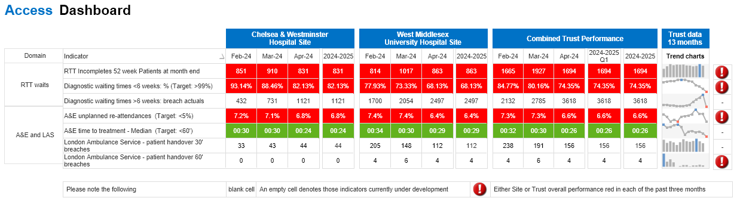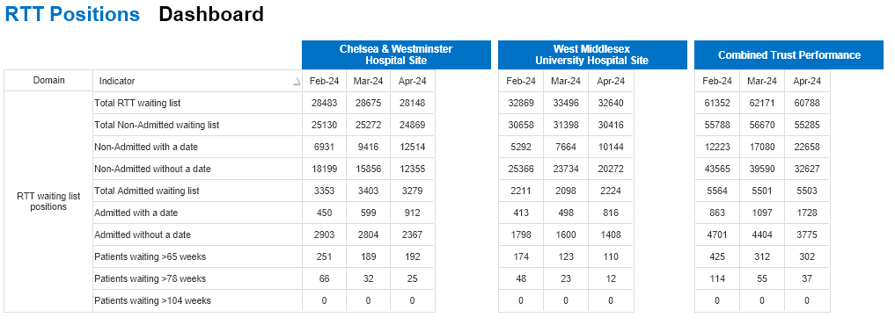

**Diagnostic 6-Week Waits (pending narrative)**

**Ambulance Handover**

Delays remain low, with handovers prioritised where possible, with just four 60-minute delays reported in month.

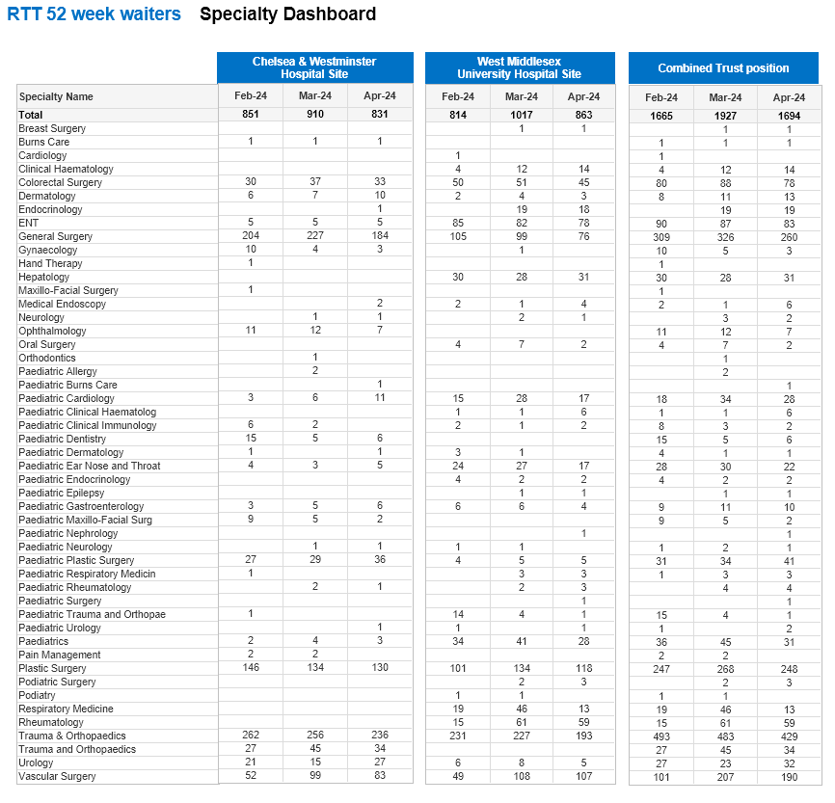

**Maternity**

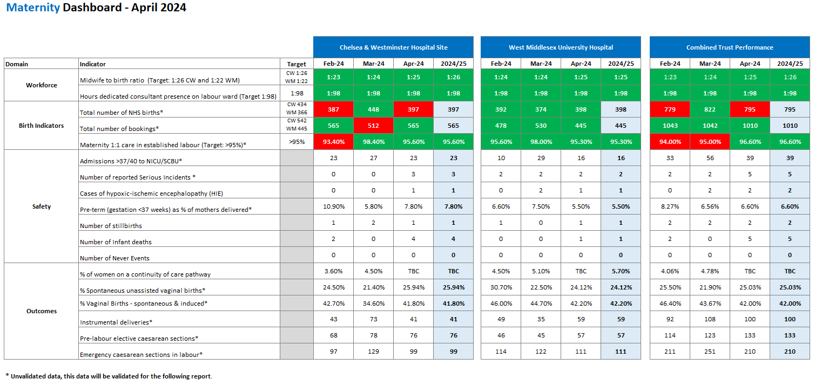

**Unvalidated data for April 2024, this will be validated for the following report.**

The above dashboard metrics covers: workforce, birth indicators, safety and clinical outcomes.

**Workforce** The current midwifery ratios on each site for the month of March are 1:25 at Chelsea and 1:25 at West Middlesex, the change in ratio on the Chelsea site is due in part to a decrease in birth rate and robust recruitment and retention planning. Quarterly recruitment days are in place alongside international recruitment. The service have completed successful international recruitment and are awaiting the arrival of 27 internationally educated midwives (IEM’s) who are expected between April and August 2024, the additional IEM PDM support roles are currently out to advert and a further recruitment day is planned for the end of June, It is expected that the IEMs will complete their preceptorship by next year. The senior team continue to monitor red flag events on a daily basis, there were 2 red flag events recorded on the Chelsea site (delay in providing pain relief n=1 and delay or cancellation of time critical activity n=1) and 2 on the West Mid (delay in providing pain relief n=2) these have been reviewed. The confidence factor decreased across both sites to 72.78% at Chelsea and West Mid is 79.44%%. Staffing is reviewed during the safety huddles as a minimum and staff redeployed accordingly. Substantive staffing gaps due to vacancy, sickness and maternity leave are backfilled with a combination of bank and agency staff. All temporary staff complete an orientation pack on arrival for their first shift. The Neonatal Nursing Business Case will be presented to Performance and improvement for the 2nd time once the private neonatal income component has been agreed to seek approval to fund the service at the recommended nursing ratio.

Both sites remain compliant for the 98 hours dedicated consultant labour ward presence and twice a daily ward rounds. The MIS year 5, safety action 4 indicates that the service must demonstrate an effective clinical workforce and acknowledge and incorporate the principles outlined in the RCOG ‘Roles and responsibilities of the consultant in providing acute care in obstetrics and gynaecology’. Data will be included in the Q4 Maternity and Neonatal Staffing Report. The workforce review for the WMUH site is now in the consultation stage with HR partner’s support. Effective February 2023, all short-term locums (less than 2 weeks) will need to be compliant with respect to the RCOG and GMC certificate of eligibility data regarding compliance will be reported in the Q4 Maternity and Neonatal Staffing Report. The paediatric workforce at WM are utilising additional locums to provide cover for the service to meet BAPM standards for a level 2. For tier 1 69% and for tier 2 77% of cover was provided to meet level 2 BAPM standards. There is an action plan in place to mitigate risk and ensure staffing is adequate for the activity and acuity as the unit moves toward a level 2 designation.

**Safety:**  The service has commenced a cross-site review of all stillbirths for 23-24 and this will be shared in the Q1 Maternity and Neonatal Quality and Safety Report.

**WMUH site**: 1 confirmed SI for MNSI: Baby for cooling Indian woman – Punjabi speaking Po+1 41+4 weeks, pathological CTG- decision for a caesarean section.  The woman was fully dilated in theatre- decision was made for an assisted vaginal birth- Forceps, preceded by one pull (and pop off) of a kiwi cup. Baby was born in poor, 2920g, Apgars of 5@1, 7@5, 7 @10 minutes.  Baby met criteria A & B for passive cooling & transferred to a tertiary unit. Baby had 72 hours of therapeutic cooling and was rewarmed. Baby subsequently had a normal MRI prior to discharge. MNSI accepted the case.

2. Potential PSII – awaiting IIRG panel decision-INC 132574 4th degree tear and colostomy

06/04/24 P0, 40+4. Attended triage, in spontaneous labour. Admitted to Birth Centre and birthed in the pool, following placental delivery, noted to have a significant tear by midwife – 4th degree tear diagnosed by senior registrar.  Repaired in theatre Discharged home on OASI bundle. Re-attended triage with complete breakdown of perineal repair, EUA with debridement of wound performed. The ongoing plan following this was for the woman to have a de-functioning with a loop colostomy, and further input from tissue viability and stoma nurses. DC home with FU

There were 149 reported incidents in March an increase from 138 Mar. Main themes arising:

1. Maternal, fetal and neonatal n=103(Maternal Obstetric Haemorrhage >1500mls n=20, Unexpected admission to SCBU n=20, Category 1 CS n=13)
2. Access to care/admissions, n=20. A decrease in reported delays from Mar. these were largely due to delay in transfer to labour ward for ongoing IOL.
3. Communication: n=8 mostly related to inadequate or incorrect handover of care

**CWH site**:  x2 confirmed (1 MNSI, x1 PSII and a further AAR/PSII at time of reporting not yet escalated)

NICU admission-seizures, brain haemorrhage- Low risk primip, BC transfer for epidural and temp attended BC in spontaneous labour. Category 1 caesarean section for prolonged deceleration and suspected sepsis. Baby born in good condition and normal cord gases. Baby admitted to NICU. Baby was intubated. Seizures were recorded in NICU. Bleed noted on CRUSS and MRI- potentially due to a fetal/neonatal stroke. No known underlying bleeding tendencies. Discharged home on day 10 with f/u

MNSI MI 037113- HIE3/NND-P0 low risk at booking. Had serial growth scans for Low PAPP-A. Spontaneous labour at term, transferred from the BC following decelerations noted. Instrumental birth and baby born in poor condition. APGARS 1@1, 3@5, 4@10. Transferred to NICU, meeting criteria for therapeutic hypothermia and decision made to commence active cooling. Decision to redirect care the following day and baby passed away.

SHOT- Blood transfusion – Patient was being cared for on postnatal ward, initial post-delivery bloods showed Hb of 76. Postnatal SHO reviewed and consented the woman for an iron transfusion. The patient received a blood transfusion when she was not consented for it.

There were 134 reported incidents in April an increase from 116 in Mar. Main themes arising:

1. Maternal, fetal and neonatal: n=42 Most reported incidents unexpected admission to NICU n=6, post-partum haemorrhage >1500mls (n=6), maternal readmissions (n=5)
2. Staffing (n=6)
3. Access to care/admission (n=18) mostly attributed to delays in transfer for care
4. ***PMRT (Cross site):*** CW site 4 NND (23, 26, 38 (? undiagnosed genetic condition) weeks gestation and 41 weeks (HIE and NND)), 1 stillbirth 28/40. WMUH x1 stillbirth at 40+2 weeks gestation and x1 NND/Stillbirth born before arrival at 24+1, body not found unknown outcome.
5. **ATAIN (Cross site):** WM site –15 admissions currently under review. March data for WM there were 16 term admissions, 13 were excluded and of the 3 reviewed all were deemed avoidable. CW there were 23 cases reviewed (13 excluded) with 5 admissions considered avoidable, respiratory support remains the most common reason for admission on the CW site and Jaundice on the WM site. Both sites remain below the national average for term admissions to the neonatal unit.
6. **Audit program:** All national and local audits have been registered and a cycle of audit and leads have been identified. SBLCBv3 (launched in May 2023) update (for all elements an action plan is in place, and this is updated in the quarterly report, the service reported compliance with over 93% of all interventions in March 2024 and an action plan is in place to achieve full compliance by March 2025.

**Element 1: Reducing smoking**: **The service are currently compliant with 9/10 interventions.**

**Element 2:** Risk assessment, prevention and surveillance of pregnancies at risk of fetal growth restriction: Current audits demonstrated compliance with risk assessments and the LMNS have approved the derogation from National Guidance regarding scanning episodes for women with considered to be at risk of IUGR. The service is currently undertaking an extensive demand and capacity assessment of USS cross site, with a view to mapping out what additional resource would be required to reach national recommendations. The service intends to move all midwifery AN appointments to 30mins by August 2024, to support the increased risk assessments and information sharing required to support this element. **Compliant with 18/20 interventions.**

**Element 3:** Raising awareness of reduced fetal movements: On both sites 100% of women presenting with RFM after 26 weeks had a computerised CTG and all women are provided with information regarding fetal movements. Rates of induction on labour are favourable against the expected standard and scanning for persistent/2nd episode of RFM are audited to be within the recommended time frame on both sites. **Compliant with 2/2 interventions.**

**Element 4:** Effective fetal monitoring during labour: On both sites 100% of women presenting with RFM after 26 weeks had a computerised CTG and all women are provided with information regarding fetal movements. Rates of induction on labour are favourable against the expected standard and scanning for persistent/2nd episode of RFM are audited to be within the recommended time frame on both sites. **Compliant with 4/5 interventions.**

**Element 5:** Reducing Pre-term Birth: Screening for asymptomatic bacteriuria has been re-established on the CW site and compliance with this is improving. Compliance on the WM remains as this was always supported by local guidelines. All elements of perinatal optimisation are currently being met. **Compliant with 26/27 interventions.**

**Element 6:** Management of Pre-existing Diabetes in pregnancy: **Compliant with 6/6 interventions.**

**Perinatal Quality Surveillance Model Board Reporting**

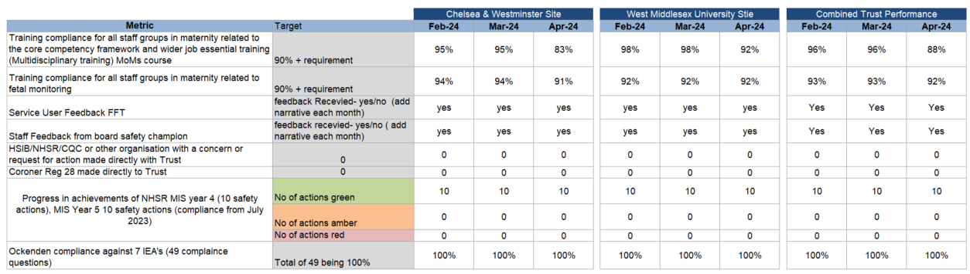

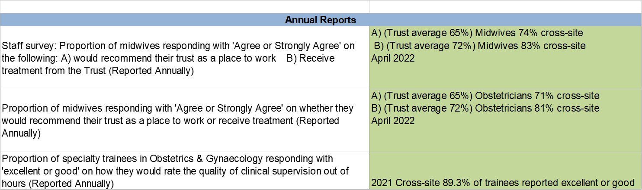

**Perinatal Quality Surveillance Model**

Chelsea and West Middlesex are not on the national maternity safety support programme as there are no concerns regarding the quality and safety of the maternity service.

Multi-professional mandatory training and fetal monitoring training: In April overall multi-disciplinary training compliance is at 88% and 92% for fetal monitoring training, there has been a decline in MOM’s compliance on the Chelsea site amongst Anaesthetic Trainee’s this is due to a new rotation and a change in guidance on those anaesthetists who are required to undertake MOM’s increasing.  All trainees have been allocated a MOM’s session and compliance is expected to improve by end of June. Training compliance is closely monitored by the senior leadership team and all staff have a training date booked. Training compliance fluctuates depending on where staff are in their training cycle.  The practice development and fetal monitoring team have a clear plan in place to ensure all staff attend both aspects of training over a rolling 12-month period.

Service user feedback: The service receives monthly friends and family test feedback and for April WM saw a decline in positive response rate from 93.15% to 82.47% with a significant decrease in response rate to 21%. CW had a sustained positive rating of 90% however this is below the 95% target. The negative scores on the WM site remain impacted by feedback related to, staff communication, attitude and behaviour and environment and on the CW site staff attitude, communication and lack of support. The Service have implemented a Postnatal Care Group in collaboration with the MNVP which aims to implement changes to improve patient experience. The Intrapartum care group has been launched across both sites and will implement changes to improve patient experience in the intrapartum pathway. The patient experience action plan has been updated to reflect the 2023 Maternity CQC Survey, with a focus support for mental wellbeing, consistency of infant feeding advice and support and the availability and consistency of information available to women, birthing people and their families.

Board safety Champion feedback: The Deputy Chief Nurse, Chief Nurse and Non-executive Director as our board safety champions undertake rotating a monthly walkabout on both sites in the maternity and neonatal services.  This feedback is captured on a survey and feedback to the maternity service safety champions.  This feedback and improvements in the service are discussed at the 6 weekly board and maternity safety champion meetings. At the next meeting the MNVP Report will be shared.

Maternity incentive Scheme year 6: The service submitted compliance with all 10 safety actions for MIS year 5. MIS year 6 was published on 2nd April 2024, the service have completed a gap analysis of the updated safety actions and this will be presented in the Q4 Maternity Quality and Safety Report. . The compliance period will end 30 November 2024 and the submission deadline with be 12:00 midday on 3 March 2025.

Interim Ockenden report (7 IEAs): The interim Ockenden was published in December 2020 and the service has been working to achieve full compliance with the report.  The service is fully compliant and will continue the audits to ensure the IEAs are embedded.

CQC Inspection (February 2023): The Care Quality Commission inspection in of the Maternity Service took place in February 2023 on both sites and received the final report in May.  Both sites have maintained their overall ratings of ‘Outstanding’ at WM and ‘Good’ at CW and the service is very proud of the continued quality and safety work that has taken place since the inspection 4 years earlier that has enabled maintaining these results with 6 areas of outstanding practice identified across the sites.  The service is now compliant with the 3 must do actions and their continued progress on the 6 ‘should do’s for the CW site and the 7 ‘should do’s’ for the WM site. 3 of the 7 actions for the WM site have been completed and 2 of the 6 on the Chelsea site. This action plan is being tracked monthly.

**Cancer Update**

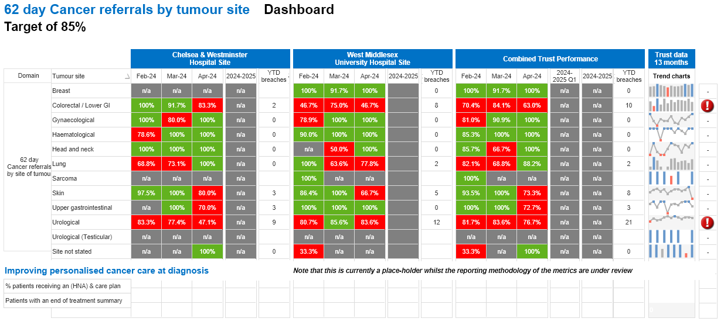

**March 2024**

**Trust Commentary**

The 62-day combined target was compliant in March 2024 with a performance of 86.89% against the 85% standard. The April position is currently unvalidated and is challenged, currently reporting 82.13% due to a high volume of breaches in Urology. Diagnostics have been somewhat challenged with reduced capacity following equipment failures in CT and MRI which has had an adverse impact on this target. Recovery plans to improve diagnostic capacity is in place and monitored at the appropriate forums.

|  |  |  |  |  |
| --- | --- | --- | --- | --- |
| **Tumour Site** | **Chelsea & Westminster** | | **West Middlesex** | |
| **Breaches** | **Treatments** | **Breaches** | **Treatments** |
| Breast |  |  | 1.5 | 10 |
| Gynaecology |  | 2.5 | 1.5 | 5.5 |
| Haematology | 0.5 | 4 | 0.5 | 10 |
| Head and Neck | 4 | 3.5 |  | 1.5 |
| Colorectal | 3.5 | 14 | 3 | 11.5 |
| Lung |  | 1.5 | 2 | 10 |
| Other |  | 4.5 |  |  |
| Skin | 1.5 | 20 | 1.5 | 12 |
| Upper GI |  | 6 | 0.5 | 8 |
| Urology | 5.5 | 17.5 | 11.5 | 35 |
| Brain |  |  |  |  |
| **Total:** | **15** | **73.5** | **22** | **103.5** |

**Safer Staffing**

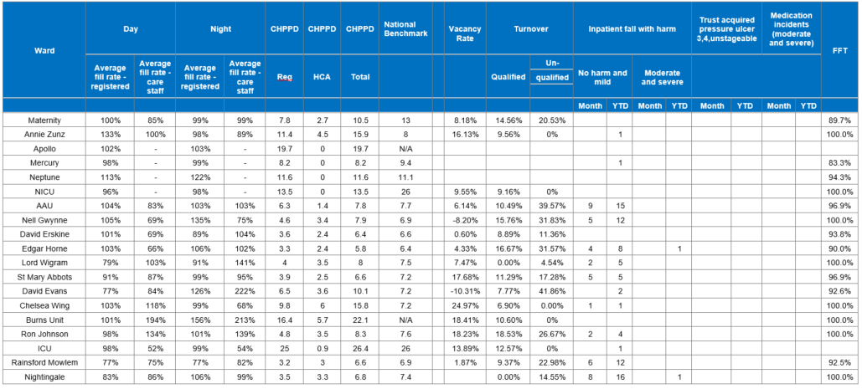**Chelsea and Westminster April 2024**

**West Middlesex April 2024**

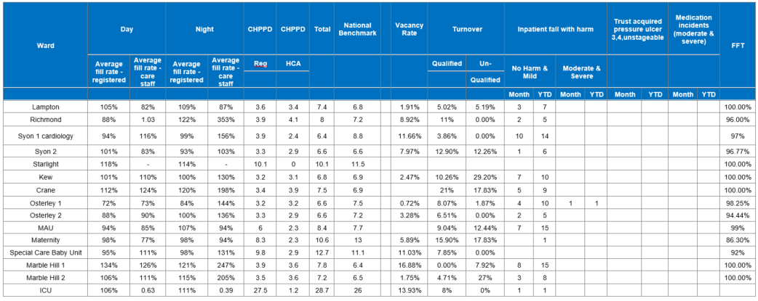**Safer Staffing & Patient Quality Indicator Report**

**April 2024**

The purpose of the safe staffing and patient quality indicator report is to provide a summary of overall Nursing & Midwifery staffing fill rates and Care Hours per Patient Day (CHPPD) and NICE red flag categories with a review of trends in the previous six months. This is then benchmarked against the national benchmarks and triangulated with associated quality indicators and patient experience for the same month. Overall, key concerns are areas where the staffing fill rate has fallen below 80% and to understand the impact this may have on patient outcomes and experience. Twice daily nurse staffing meetings continue to deploy staff as required in order to maintain patient safety.

**West Middlesex site:**

Marble Hill 1 and Marble Hill 2 had increased RN fill rate due to patients requiring RMN support. Lampton, Marble Hill 1 had a high staffing fill rate of HCAs at night due to the annexes being open and requiring additional HCAs to observe confused patients at risk of falls and those mental health patients requiring 2:1 and 1:1 observation. Additionally, Lampton and Marble Hill 2 required additional RN day and night due to the annexe being open. Kew ward has a high fill rate for HCAs during the day due to bay nursing and 1:1 care for confused patients at risk of falls. Syon 1 increased fill rate for HCAs day and night due to the annex opened for escalation beds. The reduced HCA fill rate on DRU reflects the adjustment to the patient staffing and acuity level on the unit.

Richmond required additional HCAs day and night due to additional escalation beds, high acuity of patients and 1:1 observation of confused patients at risk of falling. Osterley 1 & 2 had a high fill rate of HCA at night due to an increased number of confused medical patients at risk of falls.

Starlight ward had high RN fill rate for days due to staff sickness and an increase number of patient requiring 1:1 care. SCBU had low RN fill rate on nights due to sickness not being filled by bank. CHPPD not compromised as staff skill mix moved cross-site to support area.

**Chelsea and Westminster site**

Lord Wigram and David Evans had low HCA fill rates, these vacancies were filled by supernumerary IEN staff awaiting NMC pin numbers. CHPPD was not compromised. Saint Mary Abbot had increased HCA fill rate at night due to specialing increased risk of falls patients awaiting placement.

There was increased RN and HCA fill rate on Burns due to increased acuity in Burns ITU and patients requiring 1:1 care to maintain safety.

The high fill rate on Annie Zunz was due to increased planned admissions with patients admitted via the Surgical Admissions Lounge. The high HCA fill rate on Ron Johnson, days and nights was due to a patient requiring an additional two HCAs to maintain safety. The additional RN fill rate staffed the GDU escalation area. Chelsea Wing required additional RN cover day and night due to a patient requiring 1:1 care.

Nell Gwynne had high fill rate for RN during the night due to patients requiring additional support with tracheostomy care. Low day and night shift HCA fill rates result from unfilled shifts due to sickness not being covered by bank. Nightingale ward had high fill rates for RN and HCAs due to escalation beds opening, and required increased cover at night. Rainsford Mowlem, David Erskine and Edgar Horne had low HCA fill rate during the day due to sickness and being unable to cover HCA shifts with bank, CHPPD was not compromised as staff were redeployed between wards and ward managers assisted.

**Incidents:**

In terms of incidents with harm, there were four incidents reported this month:

The medication incident on Starlight resulted in a paediatric patient experiencing a post-infusion seizure after receiving an adult dosage. The patient was discharged without any discernible long-term effects. The medication incident on Osterley 2 involved a patient who sustained a subdural bleed following recommencement of anticoagulant medications. The patient remains under the haematology care.

The falls incident at WM occurred on Syon 2 ward. The patient sustained a fractured arm following a fall during a therapy session. The patient did not require surgery but remains in a cast. The patient on AAU sustained a fractured neck of femur following a fall on the ward. The patient has end stage Parkinson’s and is for palliative care currently. The fracture has been treated conservatively.

Friends and Family test showed that five wards at CW and seven at WM scored 100%. Starlight FFT reported concerns from relatives regarding delays in transfers to specialist beds. This remains an ongoing issue. Maternity FFT reported increased activity in April, which caused delays in appointments and scheduling in addition to the bank holidays reduced clinic numbers. Both areas are aware, and are actively trying to improve the patient experience. Please note all incident figures are correct at time of extraction from DATIX. There were five red flags raised in April .Four were for CW & one at West Mid, mainly related to staffing shortfalls and agency staffing levels and unplanned omission in providing medication. The vacancy rate and turnover are from March.

**Safe Staffing Analysis | Registered Nurse and Care Staff April 2024**



**RN Fill Rates (ward areas)** increasedfrom 103.41% in March 2024 to 106.13% in April 2024. The RN vacancy rate (whole trust) in March 2024 was 5.24%.

**Care Staff Fill Rates (ward areas)** decreased from 108.89% in March 2024 to 102.80% in April 2024. There has been an extensive HCA recruitment campaign maintained over the last few months. The HCA vacancy rate (whole trust) in March 2024 was 11.69%

**The Trust overall fill rate (ward areas)** (RN and Care Staff combined) decreased from 106.15% in March 2024 to 104.46% in April 2024.

**Care Hours per Patient Day (CHPPD)** continues to be collated on a monthly basis. The most current Trust measure from the Model Hospital* (Dec 2023) was 8.7. Trust workforce data confirms the CHPPD was 8.8 in April 2024, up from March 2024 – 8.7

**Safe Staffing Red Flags** – 5 red flags from the 5 categories (tables below) were reported during April 2024 where majority of them were Missed ‘intentional rounding’.

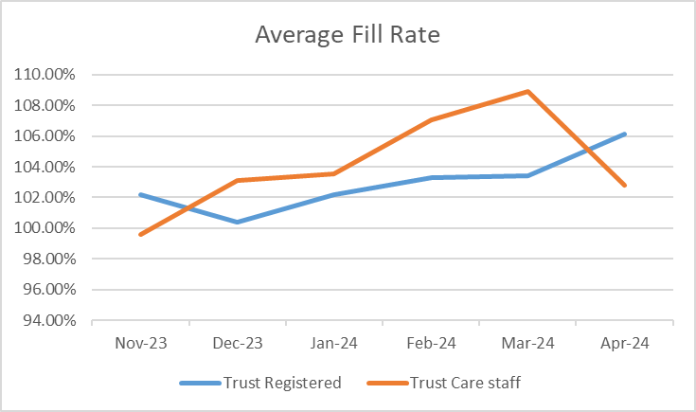



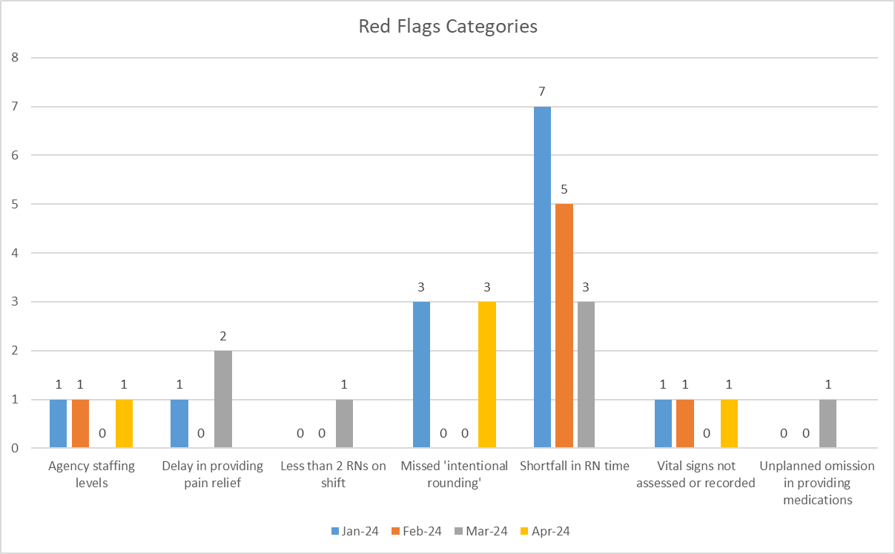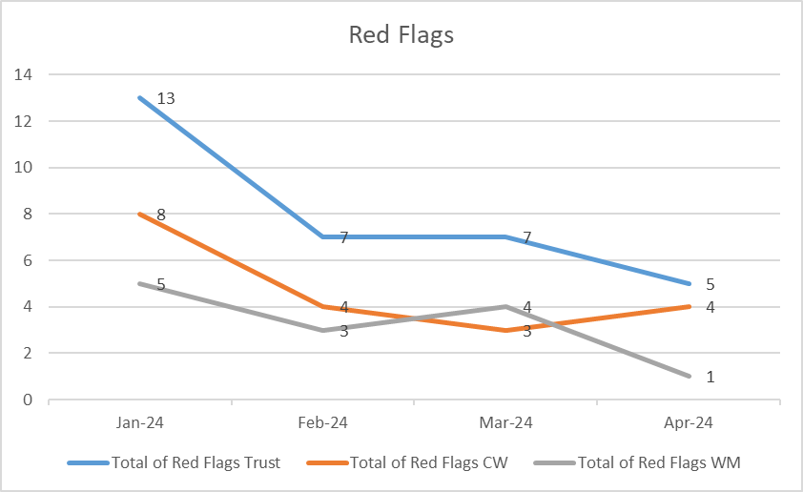

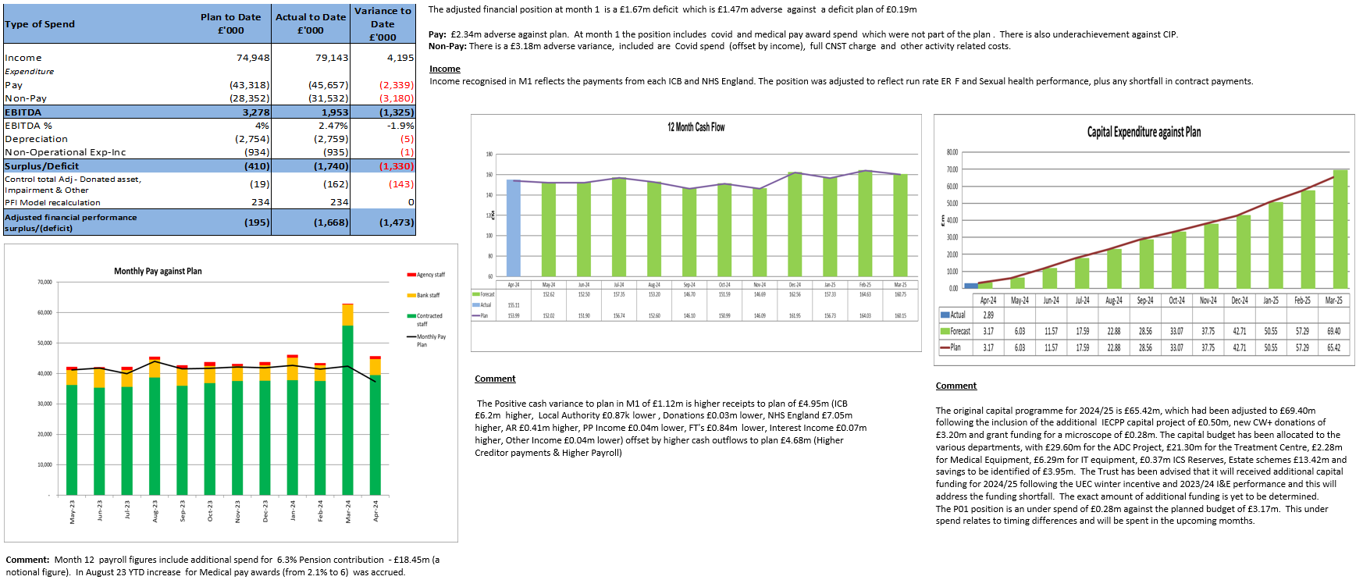

**Finance M1 (April 2024) 2024/2025**